Phase 1 – Setup & Attack

Catalog
Step 1: Install Virtual Machines (VMs) 2
1. Download & Install VirtualBox 2
Step 2: Set Network to Host-Only 3
1. In VirtualBox: 3
2. Start both VMs 5
3. In Kali terminal, type: 5
Step 3: Attack with Metasploit (FTP Example) 6
1. Open Kali Linux & Launch Metasploit 6
2. Search for an FTP Exploit 7
3. Use the Exploit 7
4. Set the Target IP 7
5. Launch the Attack! 7
Task 1.2 Create a Custom Script (Simple Python Example) 8
1. Open a Text Editor in Kali 8

Step 1: Install Virtual Machines (VMs)

1. Download & Install VirtualBox
- What? VirtualBox lets you run multiple OS (like Kali & Metasploitable) on your computer.
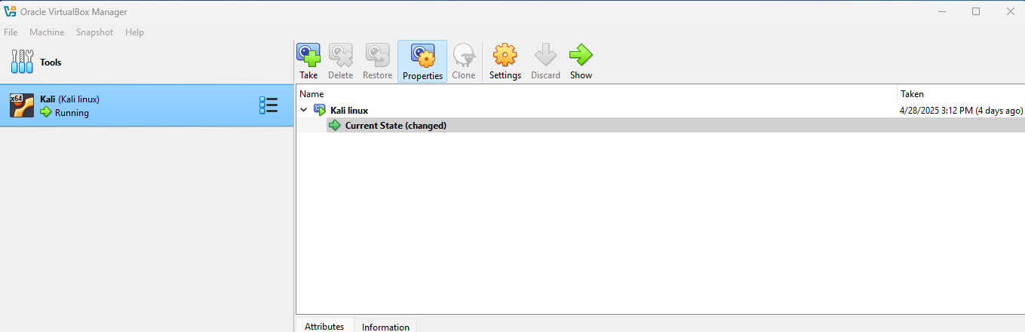

2. Download Metasploitable3 (Victim Machine)
- What? A purposely weak machine for hacking practice.
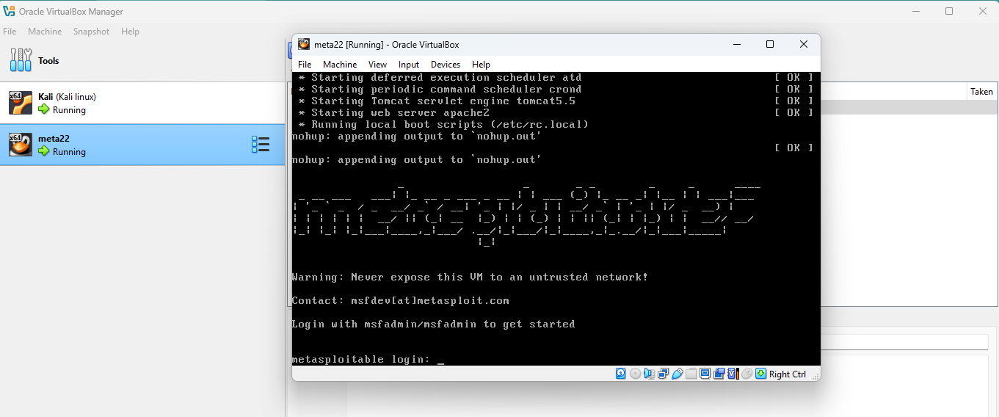

3. Download Kali Linux (Attacker Machine)
- What? A Linux OS with hacking tools pre-installed.


Step 2: Set Network to Host-Only
Make sure both VMs (Kali and Metasploitable3) are on the same network.

In VirtualBox:
  - Select Kali → Settings → Network
    - Adapter 1: Select “Host-only Adapter”
  - Do the same for Metasploitable3
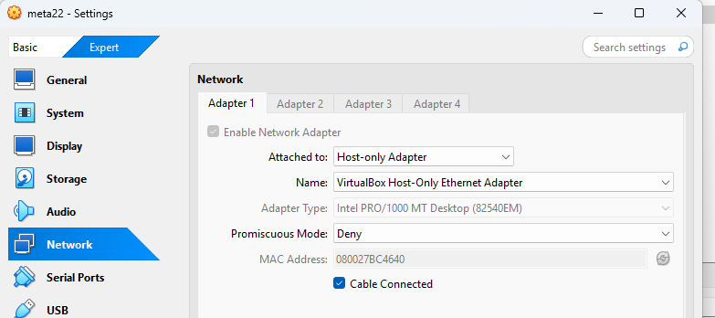
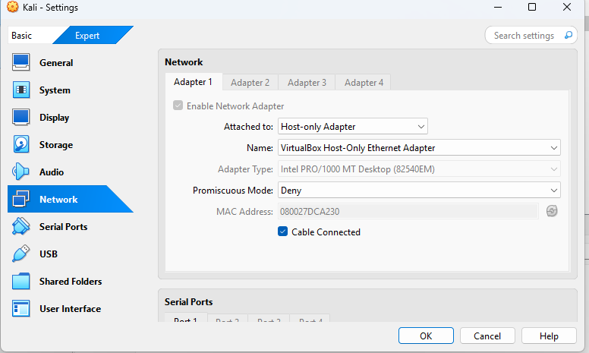

Start both VMs

In Kali terminal, type:
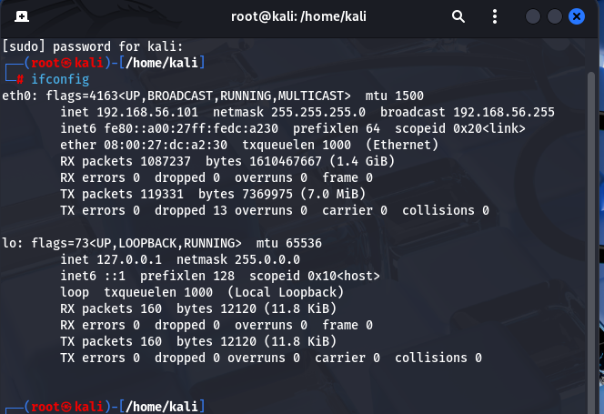

• Look for IP like 192.168.56.101
• In Metasploitable3 (Windows), open CMD:

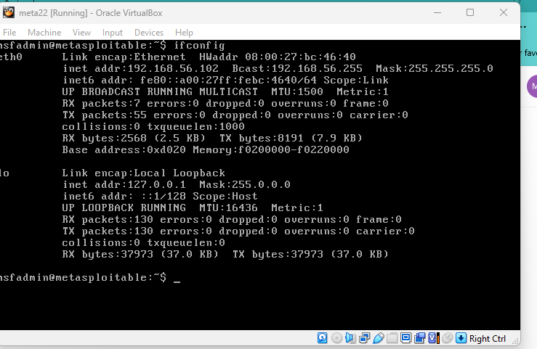
Look for IP like 192.168.56.103

Step 3: Attack with Metasploit (FTP Example)

1. Open Kali Linux & Launch Metasploit
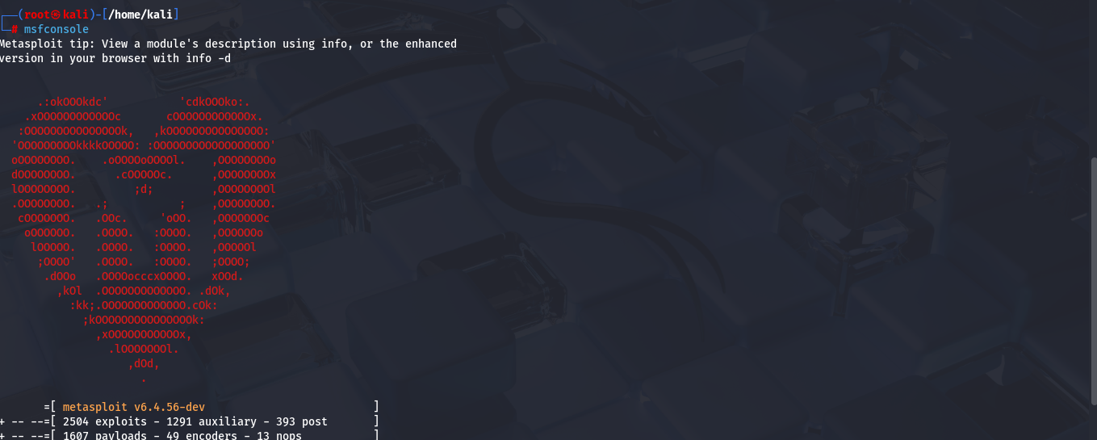

Search for an FTP Exploit

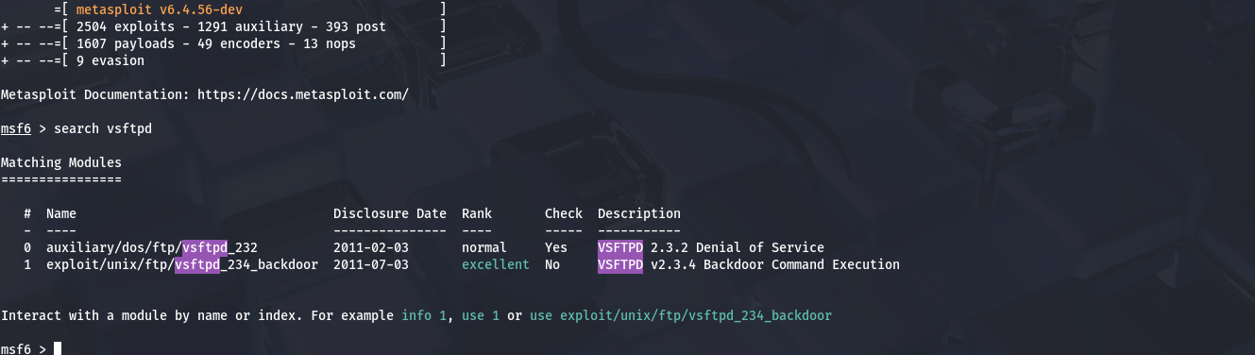

Use the Exploit

Set the Target IP
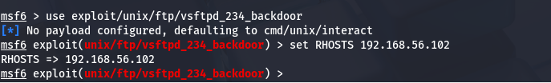

5. Launch the Attack!

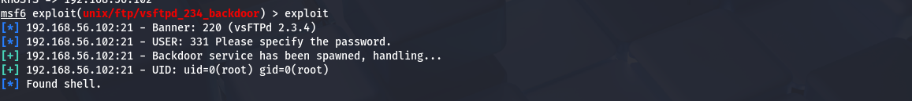

Task 1.2 Create a Custom Script (Simple Python Example)

Open a Text Editor in Kali
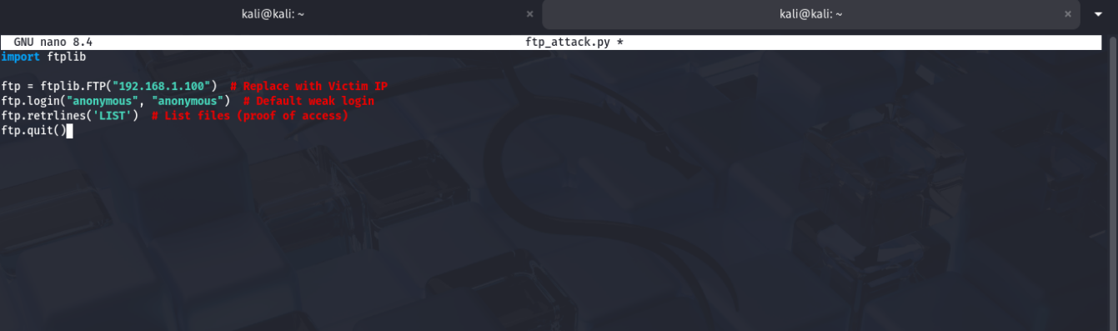

2. Run the Script

